**Electronic Supplementary Material**

**Supplement to the article:**

Ratcliff, C. L., Wong, B., Jensen, J. D., & Kaphingst, K. A. (2021). [**The impact of communicating uncertainty on public responses to precision medicine research**](https://academic.oup.com/abm/advance-article-abstract/doi/10.1093/abm/kaab050/6326654). Annals of Behavioral Medicine.

Contents:

S1. Experimental Stimuli

S2. Participant Characteristics

S3. Uncertainty Perceptions and Outcomes by Article Condition

S4. Supplemental Analyses for Willingness to Participate

S5. Diagram of Significant Conditional Direct and Indirect Paths

S6. Supplemental Analyses for Perceived Ethicality

**S1. Experimental Stimuli**

**Stimulus Layout**

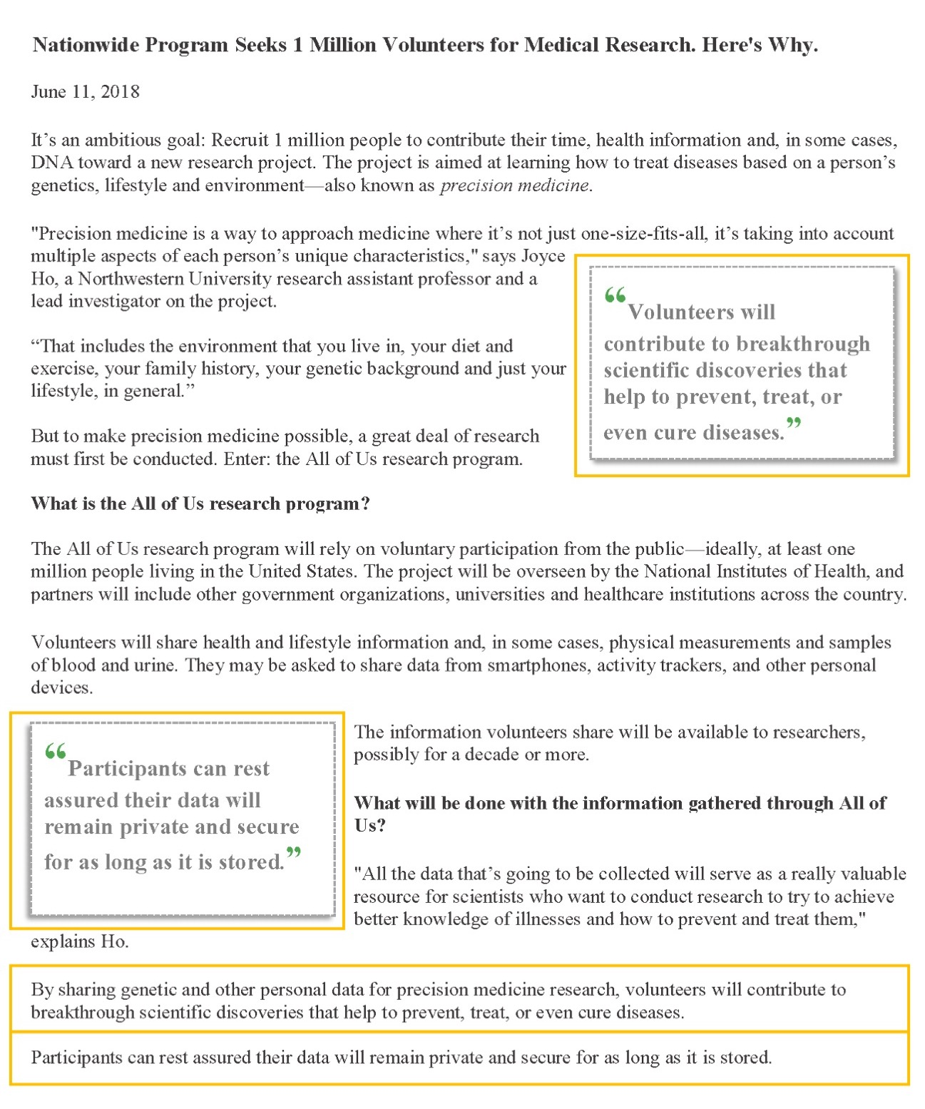

*Notes*. Manipulated sections are highlighted here with a yellow border but were not highlighted in the actual experiment. Manipulated text for each condition is displayed in the table below.

**Supplementary Table 1. Manipulated Text**

|  |  |  |
| --- | --- | --- |
|  | **Scientific Utility** | **Data Governance** |
| **No Uncertainty Condition**  Word count: 340 | **Statement 1:** By sharing genetic and other personal information for precision medicine research, volunteers will contribute to breakthrough scientific discoveries that help to prevent, treat or even cure diseases.  **Callout box 1:** “Volunteers will contribute to breakthrough scientific discoveries that help to prevent, treat, or even cure diseases.” | **Statement 2:** Participants can rest assured their data will remain private and secure for as long as it is stored.  **Callout box 2:** “Participants can rest assured their data will remain private and secure for as long as it is stored.” |
| **Scientific Uncertainty Only Condition**  Word count: 368 | **Statement 1:** But the limits of biomedical science should be acknowledged. Developing highly tailored ways to prevent, treat or cure diseases is challenging and complex. There can be no guarantee that every participant’s data will be used for research, or that the research will lead to useful scientific findings that impact our healthcare.  **Callout box 1:** “But the limits of biomedical science should be acknowledged … There is no guarantee of breakthrough scientific discoveries.” | **Statement 2:** With regard to their data, participants can rest assured their data will remain private and secure for as long as it is stored.  **Callout box 2:** “Participants can rest assured their data will remain private and secure for as long as it is stored.” |
| **Data Uncertainty Only Condition**  Word count: 398 | **Statement 1:** By sharing genetic and other personal information for research, volunteers will be contributing to breakthrough scientific discoveries that help to prevent, treat or even cure a host of diseases.  **Callout box 1:** “Volunteers will contribute to breakthrough scientific discoveries that help to prevent, treat, or even cure diseases.” | **Statement 2:** But the limits of data privacy and security should be acknowledged. Though steps will be taken to protect the privacy and security of participants’ data, there can be no guarantees. No database is 100% safe from hackers or human error. And in these exploratory stages of research, participant data will likely be stored for future undetermined uses. In other words, who will access the data and for what research purposes is not yet known.  **Callout box 2:** “But the limits of data privacy and security should be acknowledged … Though steps will be taken to protect participant data, there are no guarantees.” |
| **Both Uncertainty Condition**  Word count: 420 | **Statement 1:** But the limits of biomedical science should be acknowledged. Developing highly tailored ways to prevent, treat or cure diseases is challenging and complex. There can be no guarantee that every participant’s data will be used for research, or that the research will lead to useful scientific findings that impact our healthcare.  **Callout box 1:** “But the limits of biomedical science should be acknowledged … There is no guarantee of breakthrough scientific discoveries.” | **Statement 2:** Volunteers should also be aware that there can be no guarantee of data privacy and security. Though steps will be taken to protect the privacy and security of participants’ data, no database is 100% safe from hackers or human error. And in these exploratory stages of research, participant data will likely be stored for future undetermined uses. In other words, who will access the data and for what research purposes is not yet known.  **Callout box 2:** “Though steps will be taken to protect the privacy and security of participant data, no database is 100% safe from hackers or human error.”  (This differs slightly from the data uncertainty only callout so that it would not be too similar to callout box 1.) |

*Notes*. Some other parts of the article were modified for the purposes of this study. The original article was retrieved from:https://www.chicagotribune.com/business/ct-biz-back-story-joyce-ho-northwestern-medicine-20180610-story.html.

**S2. Supplementary Table 2. Participant Characteristics**

|  |  |  |
| --- | --- | --- |
|  | *N* | % |
| **Sex** |  |  |
| Female | 323 | 47.9 |
| Male | 350 | 51.9 |
| Non-binary | 1 | 0.1 |
| **Age Range** |  |  |
| 18-25 | 85 | 12.6 |
| 26-35 | 178 | 26.4 |
| 36-45 | 153 | 22.7 |
| 46-55 | 113 | 16.8 |
| 56 or older | 145 | 21.5 |
| **Race/Ethnicity\*** |  |  |
| Hispanic or Latino | 126 | 18.7 |
| White | 390 | 57.9 |
| Non-Hispanic White | 337 | 50.0 |
| Black or African American | 156 | 23.1 |
| Asian, Asian Indian or Pacific Islander | 69 | 10.2 |
| Native American, American Indian or Alaska Native | 18 | 2.7 |
| Different race† | 50 | 7.4 |
| **Political Affiliation** |  |  |
| Democrat | 323 | 47.9 |
| Republican | 143 | 21.2 |
| Independent | 174 | 25.8 |
| Other | 34 | 5.0 |
| **Income** |  |  |
| $0 - $24,999 | 137 | 20.3 |
| $25,000 to $49,999 | 179 | 26.6 |
| $50,000 to $74,999 | 147 | 21.8 |
| $75,000 to $99,999 | 87 | 12.9 |
| $100,000 to $149,999 | 81 | 12.0 |
| $150,000+ | 43 | 6.4 |
| **Highest education attained** |  |  |
| Less than high school | 19 | 2.8 |
| HS/GED | 243 | 36.1 |
| 2-year degree | 132 | 19.6 |
| 4-year degree | 201 | 29.8 |
| Advanced/professional degree | 79 | 11.7 |
| **Other characteristics** |  |  |
| Heard of precision medicine (answered *yes*) | 61 | 9.1 |
| Prior health research participation (answered *yes*) | 52 | 7.7 |
| *Notes.* *N* = 674. *Categories in this section are not mutually exclusive. †Participants’ text responses included Mexican, Dominican, Columbian, Puerto Rican, Middle Eastern, East Indian, and West Indian. | | |

**S3. Uncertainty Perceptions and Outcomes by Article Condition**

|  |  |  |
| --- | --- | --- |
| **Supplementary Table 3a. Uncertainty Perceptions by Condition** | | |
|  | Perceived Scientific Uncertainty | Perceived Data Uncertainty |
| Cond 1: Both Certain (*N*=149) | 2.31 (0.97)a | 2.70 (1.11)a |
| Cond 2: Uncertain Science (*N*=180) | **2.67 (1.06)**b | 2.73 (1.16)a |
| Cond 3: Uncertain Data (*N*=153) | 2.46 (1.01)a | **3.00 (1.15)**b |
| Cond 4: Both Uncertain (*N*=192) | **2.76 (0.97)**b | **3.14 (1.14)**b |
| *Notes*.Means are reported (standard deviations in parentheses) for the general measures of perceived uncertainty. Bolded cells are expected to be higher based on the message manipulations. Means in the same column that do not share a common superscript are significantly different at *p* < .05. | | |

|  |  |  |  |
| --- | --- | --- | --- |
| **Supplementary Table 3b. Outcomes by Condition** | | |  |
|  | Attitudes | Trust | Willingness to Participate |
| Cond 1: Both Certain (*N*=149) | 5.56 (1.44) | 3.47 (.90) | 2.22 (.93) |
| Cond 2: Uncertain Science (*N*=180) | 5.58 (1.23) | 3.59 (.79) | 2.21 (.91) |
| Cond 3: Uncertain Data (*N*=153) | 5.43 (1.42) | 3.49 (.82) | 2.29 (.97) |
| Cond 4: Both Uncertain (*N*=192) | 5.53 (1.19) | 3.52 (.81) | 2.20 (.94) |
| *Notes*.Means are reported (standard deviations in parentheses). None of the means within each column were significantly different. | | | |

**S4. Supplemental Analyses for Willingness to Participate**

### **Main Effect of Communicating Uncertainty on Willingness (Including Not Sure Responses)**

Willingness to participate was also examined as a categorical outcome with *not sure* responses included. Chi-square tests revealed no main effect on willingness to participate as a categorical outcome: there was no difference between communicating scientific certainty and uncertainty, *χ2*(3) .55, *p* = .91, or between data certainty and uncertainty, *χ2*(3) 1.27, *p* = .74, on responses. Cell frequencies are reported in the table below.

Given the non-significant chi-square results and arguments cited by Krosnick et al. (2002)[1], it was deemed reasonable to exclude this group from the main analyses for ease of interpretation.

|  |  |  |  |  |  |  |
| --- | --- | --- | --- | --- | --- | --- |
| **Supplementary Table 4. Willingness to Join by Condition (Including Not Sure Responses)** | | | | | | |
|  | Very likely  (*N*=174) | Somewhat likely (*N*=259) | Not at all likely (*N*=164) | Not sure (*N*=71) | Pearson Chi-Square |
| No Uncertainty (*N*=148) | 27.7% | 38.5% | 24.3% | 9.5% | *χ2*(9) 2.68, *p* = .98 |
| Scientific Uncertainty (*N*=179) | 25.7% | 41.3% | 23.5% | 9.5% |
| Data Uncertainty (*N*=152) | 25.7% | 38.2% | 23.0% | 13.2% |
| Both Uncertainty (*N*=189) | 25.4% | 37.0% | 27.0% | 10.6% |
| *Notes.* Reporting % within condition. There is no main effect of condition on likelihood of joining across all conditions (reported in table), or between factors (reported in main manuscript). No cell was statistically different than any other cell. Total *N* = 668 (responses were missing for 6 participants). | | | | | | |

**Characteristics of Those Responding ‘Not Sure’**

Although “not sure” survey responses are commonly removed from analyses (see Krosnick et al., 2002, p. 371), a follow-up analysis of participants reporting *not sure* was conducted to understand this group. Perceived researcher trustworthiness was significantly lower, and perceived data uncertainty was significantly higher, for this group compared to all other participants. Demographics (i.e., gender, education, income, race, and ethnicity) were not significantly different between this group and any other group.

**S5. Diagram of Significant Conditional Direct and Indirect Paths**

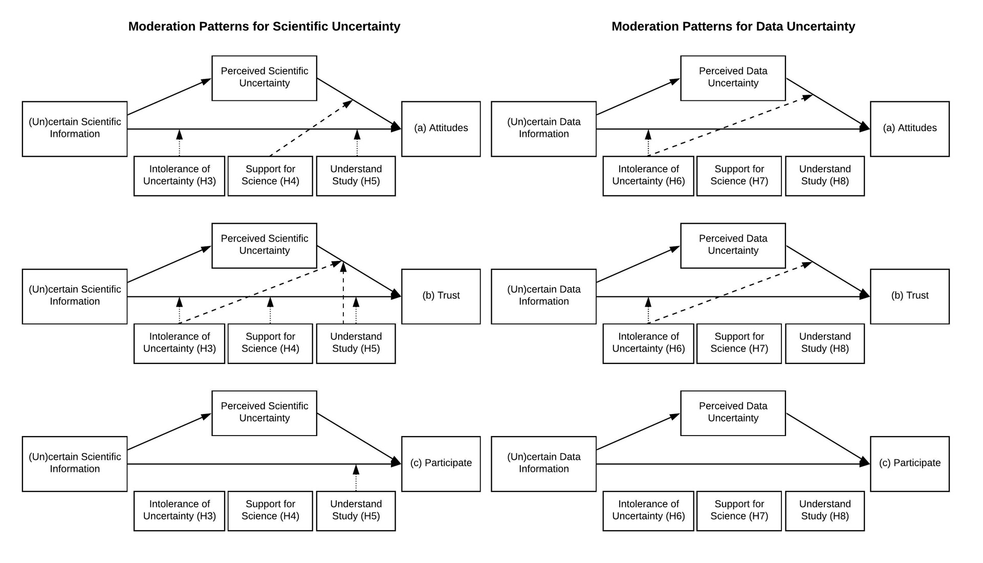

*Notes*. Figure depicts the significant moderation pathways for each conditional mediation model (PROCESS Model 59). The large dotted line denotes moderation of an indirect pathway, while the small dotted line denotes moderation of a direct pathway. Moderation of full mediation is not depicted but instead reported in text.

**S6. Supplemental Analyses for Perceived Ethicality** 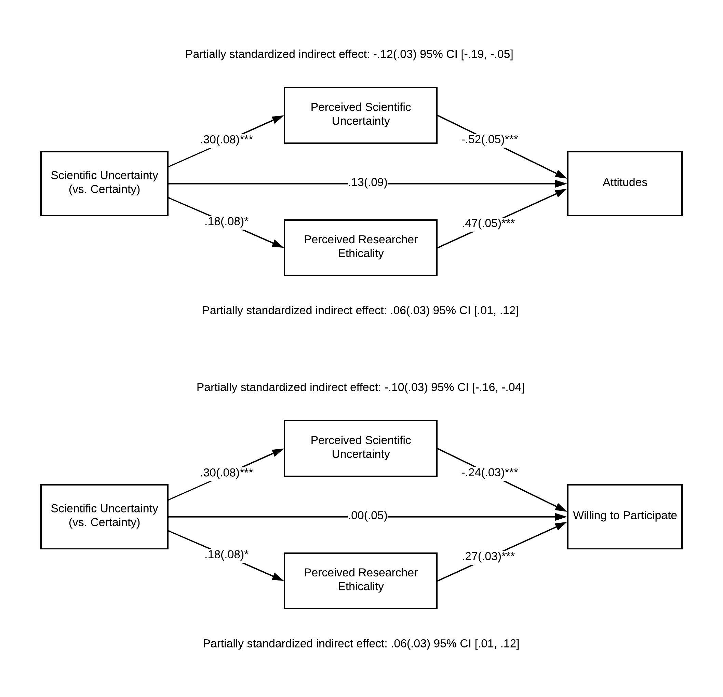

*Notes*. Parallel mediation models (PROCESS Model 4 with 5,000 bootstraps). The willingness to participate variable excludes ‘not sure’ responses.

\**p* ≤ .05, \*\**p* < .01, \*\*\**p* < .001

1. Krosnick, J. A., Holbrook, A. L., Berent, M. K., Carson, R. T., Michael Hanemann, W., Kopp, R. J., ... & Moody, W. R. (2002). The impact of" no opinion" response options on data quality: non-attitude reduction or an invitation to satisfice? *Public Opinion Quarterly*, *66*(3), 371-403.